**10 Differences Between Amateurs and Professional Analysts**

The journey to becoming a “real” data analyst



Photo by [Alexander Sinn](https://unsplash.com/@swimstaralex?utm_source=medium&utm_medium=referral) on [Unsplash](https://unsplash.com/?utm_source=medium&utm_medium=referral)

Analytics is like the writing profession: the basics are easy to get started with and it’s an art, so there are few barriers to entry and anyone can call themselves a “writer.” There’s no guarantee of quality in the title.

However, being literate enough to write some tweets hardly makes you [Toni Morrison](https://en.wikipedia.org/wiki/Toni_Morrison) or [Gabriel García Márquez](https://en.wikipedia.org/wiki/Gabriel_Garc%C3%ADa_M%C3%A1rquez)— the best writers are light-years ahead of beginners. Their observations have power. Their insights change the world.

That’s how [analytics](http://bit.ly/quaesita_sminianalytics) is too. The variance in the profession is massive. On the other hand, barriers to entry for, say, [statistics](http://bit.ly/quaesita_statistics), are higher, so the minimum level statisticians are more impressive than minimum level analysts… but there’s also a narrower range of virtuosity. I’m often far more impressed by expert analysts than by statisticians and [ML engineers](http://bit.ly/mf-ml).

There are some big differences between an amateur and an expert professional analyst and in this article, I’ll summarize 10 of them for you. For each one, I’ve got a blog post that goes deeper, so feel free to follow the trail of links down whichever rabbit hole makes you curious.

**Data pro vs amateur difference #1 — Software skills**

Professional analysts push themselves to learn the most effective — fastest and most flexible — tools for the job, which means they rapidly transcend point-and-click analytics interfaces and learn to code. If they want to lay a claim to being a pro, they build scary-good skills in least two out of these three languages: *R, Python, and SQL*. [***Learn more***](http://bit.ly/quaesita_realanalyst).

**Data pro vs amateur difference #2 — Handling lots of data with ease**

How big is “big data”? That’s depends on the technology available to you — what might have counted 10 years ago doesn’t count today. [Data](http://bit.ly/quaesita_hist) is “big” when you need [extra engineering skills](http://bit.ly/quaesita_dataeng) just to access it and move it around. It’s most certainly not “big” if you can load the whole dataset into your laptop’s memory.



Photo by [Randy Tarampi](https://unsplash.com/@randytarampi?utm_source=medium&utm_medium=referral) on [Unsplash](https://unsplash.com/?utm_source=medium&utm_medium=referral)

Unlike a newbie, the professional analyst refuses to be daunted by dataset size. If extra engineering skills are what it takes to handle it, so be it. You’ll learn whatever you must. As a result, expert analysts often pick up [data engineering skills](http://bit.ly/quaesita_dataeng) along the way. [***Learn more***](http://bit.ly/quaesita_realanalyst).

**Data pro vs amateur difference #3 — Immunity to data science bias**

Another big difference between an amateur and an expert analyst is that the expert has developed an all-encompassing disrespect for data. They never pronounce data with a capital ‘D’.

*“With data, you’re still just another person with an opinion.”*

One of my favorite pioneers of [statistics](http://bit.ly/quaesita_statistics), [W. Edwards Deming](https://en.wikipedia.org/wiki/W._Edwards_Deming), famously said that *“without data, you’re just another person with an opinion.’’* That is true, but unfortunately so is this: *“With data, you’re still just another person with an opinion.”* Expert analysts understand this in their very bones.

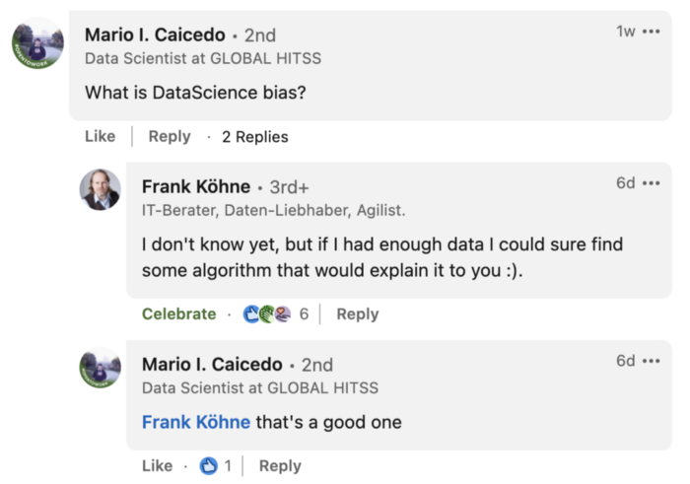

A hidden gem in the comments on one of my [LinkedIn posts.](https://www.linkedin.com/feed/update/urn:li:activity:6920441887174578176/)

Data can lull unsuspecting amateurs into a false sense of security, but experts know how to avoid quantitative gullibility. To start building the same immunity, stop treating data as special. [***Learn more***](http://bit.ly/quaesita_realanalyst).

**Data pro vs amateur difference #4 — Understanding the career**

Unlike amateurs, the professional analyst is an ***analyst by choice***, not by misfortune. To them, analytics is a discipline of excellence in its own right, not a stepping stone to some other profession (like [machine learning](http://bit.ly/mf-ml) or [statistics](http://bit.ly/quaesita_statistics)).

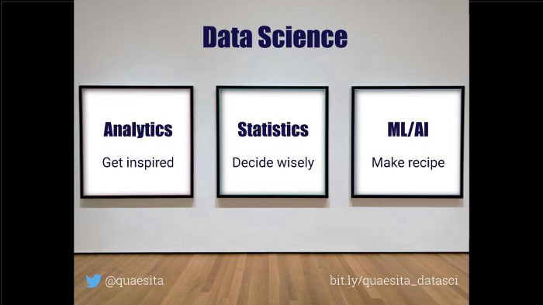

Image by the author, made for my [“What on earth is data science?” blog post](http://bit.ly/quaesita_datascim).

Professional analysts understand that it’s not your job title that makes you an analyst and it’s not the tools and technologies you use. What makes you an expert analyst is your expertise in [exploration and inspiration](http://bit.ly/quaesita_hbrrish)—so that’s the best point of departure when pondering the nuances of the analytics career. [***Learn more***](http://bit.ly/quaesita_careeranalyst).

**Data pro vs amateur difference #5 — Refusing to be a data charlatan**

Professional analysts *refuse* to be [data charlatans](http://bit.ly/quaesita_charlatan): peddlers of toxic hindsight.

The first warning sign of a data charlatan is a failure to understand that[**analytics and statistics are very different disciplines**](http://bit.ly/quaesita_battle)**.**Whatever your official [job title](http://bit.ly/quaesita_bubble), there’s no rule that says you can’t learn both trades if you want to… as long as you don’t get them confused. To avoid accidentally becoming a data charlatan, tackle these pursuits one at a time. [***Learn more***](http://bit.ly/quaesita_careeranalyst).

**Data pro vs amateur difference #6 — Resistance to confirmation bias**

[**Confirmation bias**](http://bit.ly/quaesita_confirmation)means we can all look at the same number and perceive it differently.

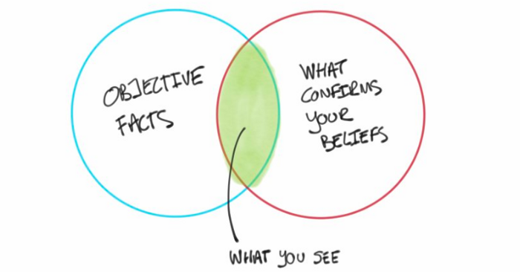

Illustration of confirmation bias by [Paul J](https://twitter.com/pivotservices/status/1062234390493884416?s=19), used with permission.

In other words, [confirmation bias](http://bit.ly/quaesita_confirmation)is the archnemesis of [data-driven decision-making](http://bit.ly/quaesita_inspired), since it means that a fact is no longer just a fact, no matter how much math and science you throw into getting it. It sucks all the value out of analyzing data.

If you’re keen to be a professional analyst, you need Jedi-level antidotes to confirmation bias. This means putting intentional practice into honing the best two skills for defending against confirmation bias: *preregistration* and *open-mindedness in the face of*[*apophenia*](http://bit.ly/quaesita_inkblot). [***Learn how***](http://bit.ly/quaesita_careeranalyst).

**Data pro vs amateur difference #7 — Realistic expectations of data**

If you’re a professional analyst, you know that data doesn’t owe you anything. Not even decent quality for your troubles.



Wading through someone else’s mess is a big part of the job for analysts. Photo by [Oleksii Hlembotskyi](https://unsplash.com/@lshphoto?utm_source=medium&utm_medium=referral) on [Unsplash](https://unsplash.com/?utm_source=medium&utm_medium=referral)

Bad data is a professional reality for analysts, in large part because their work involves spending more time with secondary data than with primary data. Analysts are painfully aware that you often need to start with bad data to figure out how to make better data. To understand why these distinctions matter and see a list of skills that help analysts cope with messy data, [***learn more here***](http://bit.ly/quaesita_realisticanalyst).

**Data pro vs amateur difference #8 — Knowing how to add value**

If you’re a decision-maker hybrid, your value is judged by the quality of your decisions and the actions you take. Your analytical skills are a means to that end — analytics is just one of many weapons in your arsenal.



An analyst acts as a sort of [sensory organ](http://bit.ly/quaesita_speed) for their decision-maker. Photo by [Gerax Sotelo](https://unsplash.com/es/@gsotelo?utm_source=medium&utm_medium=referral) on [Unsplash](https://unsplash.com/?utm_source=medium&utm_medium=referral)

If you’re a pure analyst, your value is tied to your ability to serve your decision-maker. A decision-maker’s job is to turn information into better action, which is hopeless if they can’t access much information. That’s where the analyst comes in, supporting their decision-maker’s information needs both reactively (by looking up data that answers their specific questions) and proactively (by exploring data to inspire them to consider new directions, making them more innovative and threat-proof).

An analyst acts as a sort of [sensory organ](http://bit.ly/quaesita_speed) for their decision-maker.

Expert analysts know that starting anywhere except with your decision-maker’s needs and priorities is bound to lead you astray. [***Learn more***](http://bit.ly/quaesita_valueanalyst).

**Data pro vs amateur difference #9 — Thinking differently about time**

There are few roles as laser-focused on the return-on-investment (ROI) of time.

A seasoned analyst understands that their work isn’t a sure thing with guaranteed results, but rather a time investment in inspiration, innovation, and early threat detection. That’s why they seek bosses who understand this too — bosses who don’t punish them for coming back empty-handed.



Photo by [MK Hamilton](https://unsplash.com/@mkhamilton?utm_source=medium&utm_medium=referral) on [Unsplash](https://unsplash.com/?utm_source=medium&utm_medium=referral)

If they’re working for a savvy organization, their team trusts them to make the best possible use of the time that’s allotted to them, so they’re constantly thinking in terms of the potential time ROI of their actions. To see how this guides the way expert analysts work, [***learn more here***](http://bit.ly/quaesita_timeanalysts).

**Data pro vs amateur difference #10 — Nuanced view of excellence**

The analytics game is all about optimizing inspiration-per-minute.

Unlike amateurs, expert analysts don’t view speed as a dirty word but rather as a nuanced concept that guides how they think of their work, how they prioritize, how they [assess performance](http://bit.ly/quaesita_speed), and how they develop their skills.



Photo by [Barnabas Hertelendy](https://unsplash.com/@barnabas_1?utm_source=medium&utm_medium=referral) on [Unsplash](https://unsplash.com/?utm_source=medium&utm_medium=referral)

As a professional analyst, speed is also your north star for skills development. It’s true that the data landscape is changing rapidly, so you can’t afford to stagnate. The tools you use today won’t stick around for long. Keep sharpening your claws, but don’t chase the buzzwords.

*Stop asking:* “Should I learn this tool/method/technique that all the cool kids are talking about?”  
*Start asking:* “Will learning this make me faster?”

Learn whatever makes you faster (in all the ways that matter). Since your work involves accelerating others, start by accelerating yourself. [***Learn more***](http://bit.ly/quaesita_fastanalyst).

**Practice makes perfect!**

If all you’re after is a nudge to get started with analytics, go look at some numbers already. Don’t wait for special permission. You don’t need any fancy training. Skip the courses and the books and don’t worry if you’re not an expert yet… just dive in! Feel free to call yourself an analyst as soon as looking at data starts feeling fun.

But if you’re keen to attain expert status, I have bad news for you. While I hope you’ll explore my [analytics minicourse](http://bit.ly/quaesita_sminianalytics), nothing I (or anyone else) could teach you will give you mastery. Reading about analytics can help you with mindset and attitude, but mastery takes talent and practice. Lots and lots and lots and LOTS of practice.

**[Analytics: The complete minicourse](http://bit.ly/quaesita_sminianalytics" \t "_blank)**

[One of my goals for this newsletter is to help turn the jumble of my scattered musings into coherent learning journeys…](http://bit.ly/quaesita_sminianalytics" \t "_blank)

[bit.ly](http://bit.ly/quaesita_sminianalytics" \t "_blank)

Head over to my [mini course on analytics](http://bit.ly/quaesita_sminianalytics) if you’re eager to supplement your practice sessions with some core concepts and musings on the analytics career.

Oh, and if you had fun here, see what happens if you click on the clap button more than once.